- DATES for your diary

On 5 May in Venice, as part of the opening event at the Colussi residence, actress Valentina Sperlì will perform ‘Cara Giulia’ – the letter written by Elena Re. This text captures the poetic essence of the entire project and is featured in the book LETTERA #1, to be presented over the course of the same evening.

Valentina Sperlì, following in her father’s footsteps, made her debut at a very young age in 1980 with the Compagnia del Piccolo Eliseo in Rome, before continuing her training under the direction of Gabriele Lavia, Umberto Orsini and Rossella Falk at the Teatro Eliseo, where she worked on a permanent basis for fifteen years. She continued her career at the Teatro Stabile in Turin and later at the Stabile di Emilia Romagna Teatro. During those years, she met the leading actors and directors of the Italian theatre scene, with whom she took on leading roles in many of the productions they directed. In 2019, she debuted at the Venice Biennale in the role of Liubov Andreyevna in The Cherry Orchard, directed by Alessandro Serra, which went on a national and international tour.

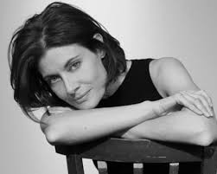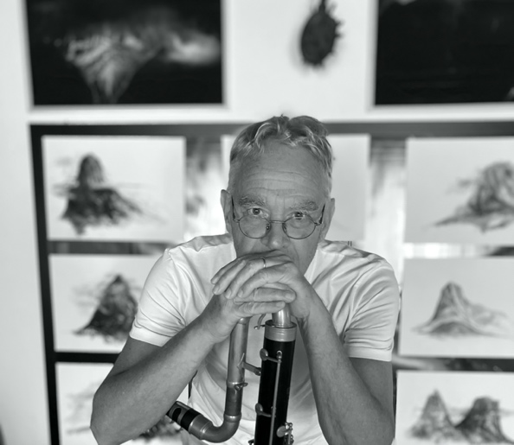
Valentina Sperlì Mauro Sambo

Also at Giulia’s home, from 6 to 10 May (between 7.30 and 8.30 pm), the artist Mauro Sambo will perform Improvvisazione sonora – a musical recital exploring the relationship between sound and place. On alternate evenings, he will be accompanied by two other musicians: Matilde Sambo and Alberto Collodel.

Mauro Sambo (Venice, 1954) develops his performative work at the intersection of sculpture, painting, photography, video and sound. He took part in the 44th Venice Biennale in the ‘Aperto 90’ section. In 2002, he held a solo exhibition titled Un lungo viaggio immobile and in 2015 presented the sound installation 5 orologi, 5 brani, 1 museo in Venice, at the Fondazione Querini Stampalia, curated by Chiara Bertola. He collaborates with musicians from all over the world and records for major independent netlabels, including Plus Timbre.

Matilde Sambo (Venice, 1993) expresses her art through various media, from sculpture to video, from sound to performance, exploring the body as a point of convergence between memory, evolution and consciousness. She has taken part in national and international exhibitions as well as artist residencies. In Venice, at the Abbey of St Gregory, her work is featured in the group exhibition A Necessary Fiction, from 6 May to 22 November 2026 – an exhibition supported and produced by the Ministry of Culture of Saudi Arabia.

Alberto Collodel (Conegliano, 1981), a musician and improviser, primarily plays the bass clarinet. He has taken part in workshops with Alvin Curran, Mats Gustafsson, William Parker, Charlemagne Palestine, Evan Parker and Steve Lehman. He is currently involved in projects in which he performs in duos, one with Marco Centasso and another with Giovanni Mancuso.
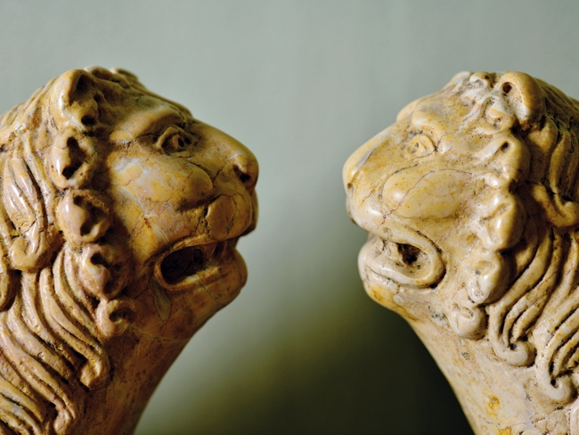

Giulia and Elena look forward to seeing you at LETTERA

Palazzo Bragadin Carabba – Calle Scaleta 6039 – Venice – doorbell: ‘Colussi’

- OPENING 5 MAY 2026, 6–10 pm

- From 6–10 May, the apartment will be visitable in the morning between 11 am and 1 pm
and in the afternoon between 5 and 9 pm.
After that, visits may be made by prior appointment +39 393 2718831

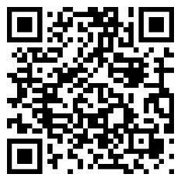
https://letteravenezia.it/download.html

