LETTERA
A project by Giulia Colussi and Elena Re

_________________

In Venice, on the second floor of Palazzo Bragadin Carabba, Giulia Colussi – a passionate collector and ‘outside-the-box’ figure – recently set up her Venetian home. At the entrance to the apartment, she decided to give over two small rooms to showcasing young art: both that of emerging talent and of artists who have only recently embarked on their careers. On some occasions, she plans to juxtapose these works with established or even historic artworks, embracing an ‘open’ perspective while, above all, highlighting the value of young artists most deserving of a space and a voice, beyond all the intricacies and complexities of the art world.

Planning her first event to coincide with the opening of the 2026 Venice Art Biennale, Giulia has chosen to present three artists: Elisa Bertaglia, Andrea Fais and Mario Uliassi. But that’s not all – this will not be the usual exhibition staged in a collector’s home, but rather a genuine cultural undertaking, an event to be repeated every year during the Biennale (both that of Art and that of Architecture), adopting the same format yet with ever-changing contributions.

Navigating the world of art, Giulia met Elena Re. In a relationship built on shared affinities and the joy of collaboration, she asked her to join this project, bringing not only her experience but also her own perspective as an art critic and independent curator. Thus, the artists’ works proposed by Giulia were explored in depth, selected together with Elena, and then displayed in this Venetian home. In this setting, Giulia and Elena happily share the conception and the scientific coordination of the project. Together they have given a name and structure to the entire project, which encompasses not only an exhibition but also a book – a publication that brings together and conveys the artists’ identities, the works involved, not to mention the sentiment that underpins the whole project. And LETTERA is the name Giulia and Elena have given to this very special venture.

Alongside the display in the apartment, the project will call upon a different guest each time, not necessarily someone from the art world. This figure will offer a sort of critical conscience – that of a keen observer who enters the space and captures its spirit, before writing a letter to Giulia to share their impressions or emotions arising from what they have seen. In this first edition (2026), Elena herself will act as the ‘pioneer’, operating as author and pilot performer, intervening both live and through her own letter published in the book. And so, over the years to follow, Giulia and Elena will invite other figures: actors, musicians, writers, philosophers, economists, scientists… From one letter to the next, a model will be outlined and a new perspective created, fostering interesting and unconventional discoveries. Thus, each year a new group of artists and a new book will form a series with its own distinct identity. The publisher is PRINP Editoria d’Arte: a small Turin-based company with a rich history to its name.

In the company of the artists, Giulia and Elena look forward to welcoming you to Venice on TUESDAY 5 MAY 2026 for a celebratory gathering in the apartment amidst the artworks. A gathering that marks the start of a journey lasting the whole year. For the house will open by appointment, with visits and cultural initiatives offering a special window onto emerging art. And the journey will also continue far beyond the apartment, for LETTERA will unfold through the accompanying publication and thus travel elsewhere, yet ever in the furrow of friendship and a pure love of things.

_________________

LETTERA

Palazzo Bragadin Carabba
Calle Scaleta 6039 – Venice
Doorbell: “Colussi”

Opening gathering:
TUESDAY 5 MAY 2026
From 6 pm to 10 pm

For further info, press office and RSVPs:
info@letteravenezia.it
+39 3932718831

https://letteravenezia.it/download.html

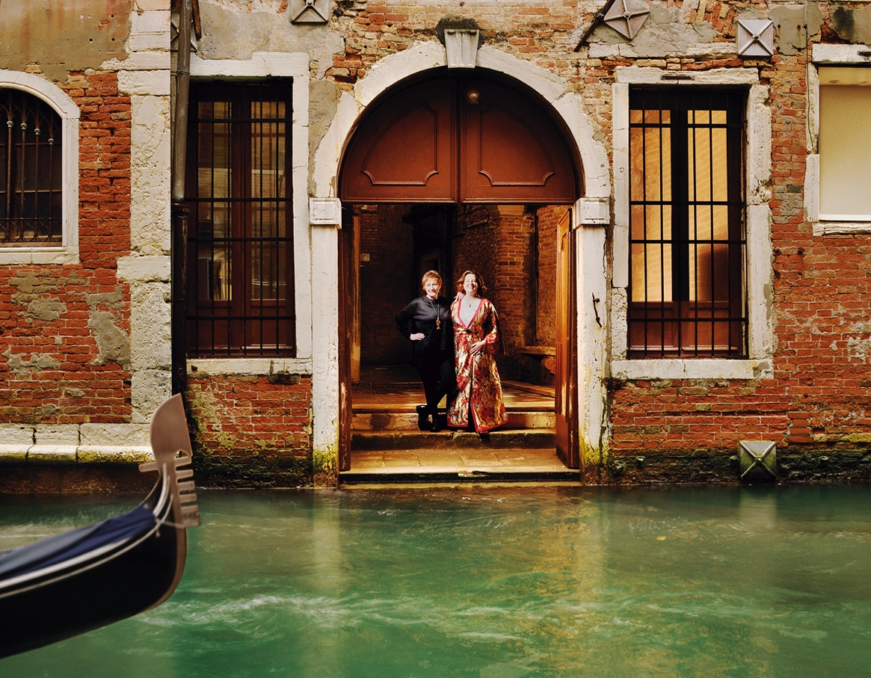

Elena Re and Giulia Colussi at the water-level door, Palazzo Bragadin Carabba, Venice 2026 (photo by Gianfranco Roselli)

